2025 MA Little League State Tournament
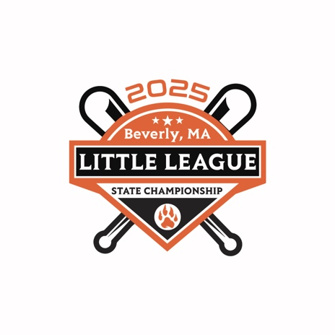
Luncheon & Officials Meeting
Thursday, July 24th, 12:00pm
Beverly Golf & Tennis
134 McKay Street, Beverly, MA
Mandatory for Team Managers, Coaches, and Umpires
All District Administrators invited

Contact Info
Shawn Murphy, President, Beverly Little League Cell: 623-512-2830
Email: shawnbmurphy@gmail.com
Dave Gotts, District 15 Administrator Cell: 617-680-8850
Email: dgotts8537@aol.com

If you have any questions, problems, or concerns, please do not
hesitate to contact either person above

2025 MA Little League State Tournament
State Tournament Schedule
Harry Ball Complex
408 Essex Street, Beverly, MA

Thursday, July 24
12:00pm – Officials Luncheon Meeting
4:30pm – Section 1 vs. Section 2
6:30pm – Opening Ceremonies
7:30pm – Section 3 vs Section 4

Friday, July 25
5:00 pm – Loser Game 1 vs. Loser Game 2
7:30 pm – Winner Game 1 vs. Winner Game 2

Saturday, July 26
11am – Winner Game 3 vs. Loser Game 4

Sunday, July 27
11am – Championship Game - Winner Game 4 vs. Winner Game 5
2025 MA Little League State Tournament
Preferred Hotel
Homewood Suites by Hilton Boston-Peabody
57 Newbury Street - Route, US-1, Peabody, MA
https://hil.tn/ijpxka
Hampton Inn Boston/Peabody
59 Newbury Street - Route, US-1, Peabody, MA
https://hil.tn/jc6yrr

Parking
General Parking
Harry Ball Complex, 408 Essex Street, Beverly
Thoreau Circle, Beverly (Overflow)
NO PARKING ON RAMP TO 128
Reserved Parking*
Harry Ball Complex, 408 Essex Street, Beverly
* Pass Required – Distributed at Luncheon

2025 MA Little League State Tournament
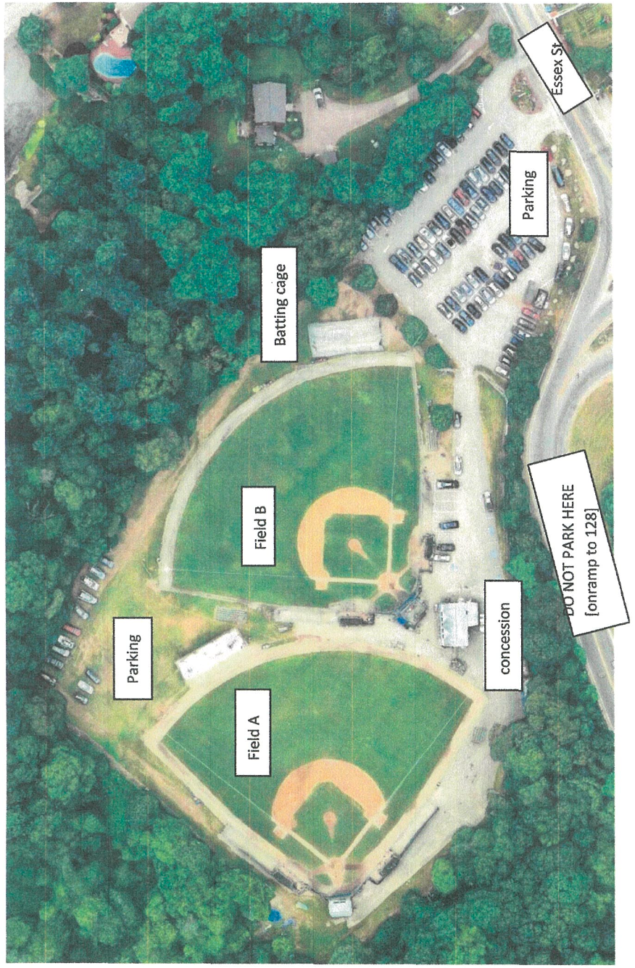
Harry Ball Complex

Overflow Parking on Thoreau Circle
No Dogs Allowed at Harry Ball Per City Ordinance

